UNIT 2
Mobile Operating System

2.1 Introduction to Mobile Operating System
A mobile operating system is an operating system that helps to run other application software on mobile devices. It is the same kind of software as the famous computer operating systems like Linux and Windows, but now they are light and simple to some extent. Mobile communication devices have been the most adopted means of communication both in the developed and developing countries with its penetration more than all other electronic devices put together. Every mobile communication device needs some type of mobile operating system to run its services: voice calls, short message service, camera functionality, and so on. The earlier mobile operating systems were fairly simple, since the capabilities of the phones they supported were limited.
The evolution process is naturally driven by the technology advancements in hardware, software, and the Internet. The technological advancements have resulted in a variety of different competing mobile operating system solutions on the market. The operating systems found on smartphones include Symbian OS, iPhone OS, RIM's BlackBerry, Windows Mobile, Palm WebOS, Android, and Maemo. Android, WebOS, and Maemo are all derived from Linux. The iPhone OS originated from BSD and NeXTSTEP, which are related to Unix.

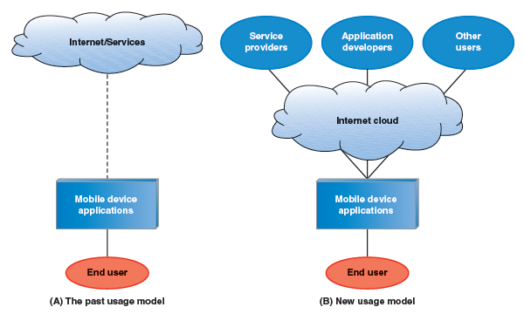

2.2 Need and effectiveness of Mobile Operating System
Need of Mobile Operating Systems:
- User Interface and Experience: Mobile operating systems provide a user-friendly interface tailored for touchscreen devices. They handle everything from app management to notifications and settings, ensuring a smooth and intuitive user experience.
- Hardware Management: Mobile OSs manage and optimize the hardware of mobile devices, including processors, memory, and sensors. They enable efficient operation and longevity of device components.
- Application Compatibility: Mobile OSs create a platform for apps to run. They provide APIs and frameworks that developers use to build applications, ensuring compatibility and integration with the device’s hardware and other apps.
- Security: Mobile OSs implement various security measures, such as encryption, app sandboxing, and secure boot processes, to protect user data and ensure the integrity of the device.
- Connectivity: They manage network connections, such as Wi-Fi, Bluetooth, and cellular data, enabling seamless communication and internet access.
- Resource Management: Mobile OSs efficiently manage system resources like battery life and memory, optimizing performance and extending device usage time.
Effectiveness of Mobile Operating Systems:
- Performance: Effective mobile OSs provide smooth and responsive performance, even with limited hardware resources. They optimize CPU usage, memory allocation, and power consumption.
- App Compatibility: A well-designed mobile OS ensures broad compatibility with a wide range of applications. This includes backward compatibility with older apps and forward compatibility with newer ones.
- Security: Effective mobile OSs offer robust security features, including regular updates and patches, to protect against vulnerabilities and threats. They also provide tools for secure app installation and data protection.
- User Experience: The effectiveness of a mobile OS can be measured by its ease of use and customization options. A good OS provides a coherent and intuitive user experience, with easy navigation, personalization options, and accessibility features.
- Development Support: The effectiveness of a mobile OS is also reflected in the support it offers developers. This includes comprehensive documentation, development tools, and support for a wide range of programming languages and frameworks.
- Updates and Maintenance: A well-maintained mobile OS regularly provides updates that enhance functionality, fix bugs, and improve security. Effective OSs have a reliable update mechanism that keeps devices up-to-date.

2.2 Types of Mobile Operating System
The popular platform of mobile operating systems are:

2.3.1 Android
The Android operating system is the most popular operating system today. It is a mobile OS based on the Linux Kernel and open-source software. The android operating system was developed by Google. The first Android device was launched in 2008. Most of the Android core is released under the open source Apache License but a large amount of software on Android devices (such as such as Play Store, Google Search, Google Play Services, Google Music, and so on) are proprietary and licensed.
Android uses a Linux kernel with higher-level APIs written in C and applications are normally programmed in Java and run with the Dalvik virtual machine (DVM) using just-in-time compilation to translate Java byte code into Dalvik dex-code.
Note: Dalvik virtual machine is an android virtual machine optimized for mobile devices.

The Android platform contains the following layers:
- Linux Kernel: Android relies on Linux for core system services such as security, memory management, process management and so on.
- Android Runtime: it provides a set of core libraries which supports most of the functionality in the core libraries of Java. The Android Virtual Machine known as Dalvik VM relies on the Linux kernel for some underlying functionality.
- Libraries: Android includes a set of C/C++ libraries. These libraries are exposed to developers through the Android application framework. They include media libraries, system C libraries, surface manager, 3D libraries, SQLite and so on.
- Application Framework: it provides an access layer to the framework APIs used by the core applications. It allows components to be used by the developer.

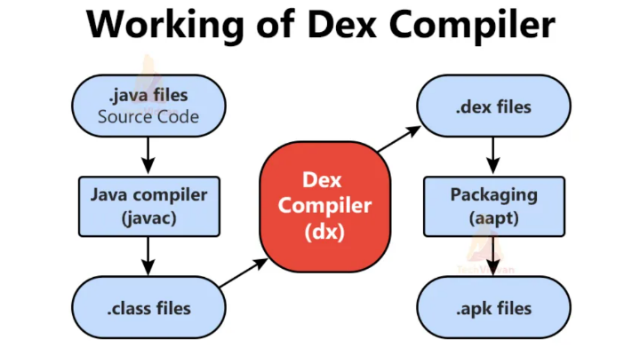
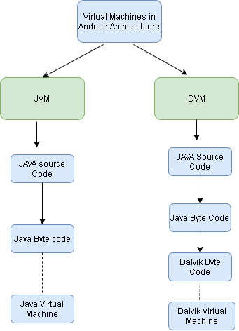

You will find all the Android application at the top layer. You will write your application to be installed on this layer only. Examples of such applications are Contacts Books, Browser, Games etc.
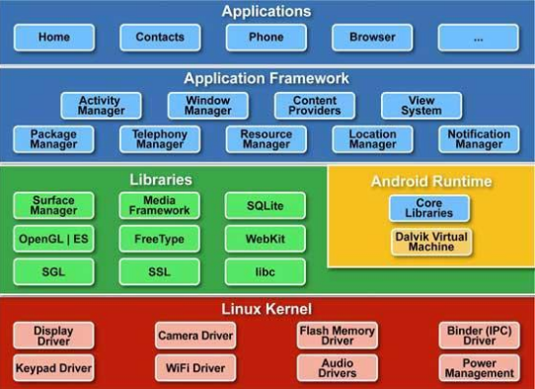

2.3.2 IOS
iOS (previously iPhone OS) is a mobile operating system developed by Apple Inc. and distributed exclusively for Apple hardware. It is the operating system that powers iPhone, iPad, iPod Touch, and Apple TV. It is closed source and proprietary and built on open-source Darwin core OS. iOS promoted a new style of user interaction for small screen, limited input devices, specifically, direct manipulation. Touch-based gestures like swipe, tap, tap and hold, and pinch are used to control on-screen interface elements, and to perform interface operations. Accelerometers support additional physical gestures like shaking and rotating the orientation of the device.
iOS is derived from Mac OS X, and shares its basic Darwin foundation, an open-source POSIX-compliant UNIX OS. In this sense iOS can be considered a variant of UNIX.
Note: POSIX (Portable Operating System Interface)
The structure of the iOS operating System is Layered based. Its communication doesn’t occur directly. The layers between the Application Layer and the Hardware layer will help for Communication. iOS is made up of four abstraction layers: Core OS, Core Services, Media, and Cocoa Touch6
Core OS
All the IOS technologies are built under the lowest level layer i.e. Core OS layer. These technologies include:
- Core Bluetooth Framework
Apples framework for communication with Bluetooth low energy device.
- External Accessories Framework
For any gadget to communicate with an iOS device, the gadget manufacturer should enroll themselves to Apple’s MFi program.
- Accelerate Framework
The Accelerate Framework is used to make large-scale mathematical and image calculations much easier for developers and optimized for high performance tasks.
- Security Services Framework
- Local Authorization Framework etc.
Note: A Bluetooth device can either be central or peripheral.
Core Service
Core Services: Fundamental system-services, which are subdivided in different frameworks and based on C and Objective C. Some important frameworks are present in the CORE SERVICES Layer which helps the iOS operating system to cure itself ad provide better functionality. It includes basic application services, including accounts, contacts, networking, data management, location, calendar events, SQLite, and XML support.
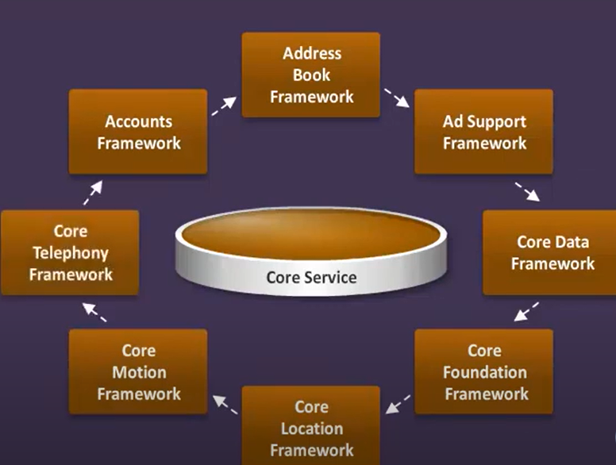
Media Layer
Considers the high-level frameworks, which are responsible for using graphic (support for 2d and 3d graphics), audio and video technologies. With the help of the media layer, we will enable all graphics video, and audio technology of the system.
Cocoa Touch:
The UIKIT, which is an Objective- C based framework and provides a number of functionalities, which are necessary for the development of an iOS Application like the User Interface Management. It also includes APIs for building applications—multitasking, touch input, notifications, interface views, and access to device data.

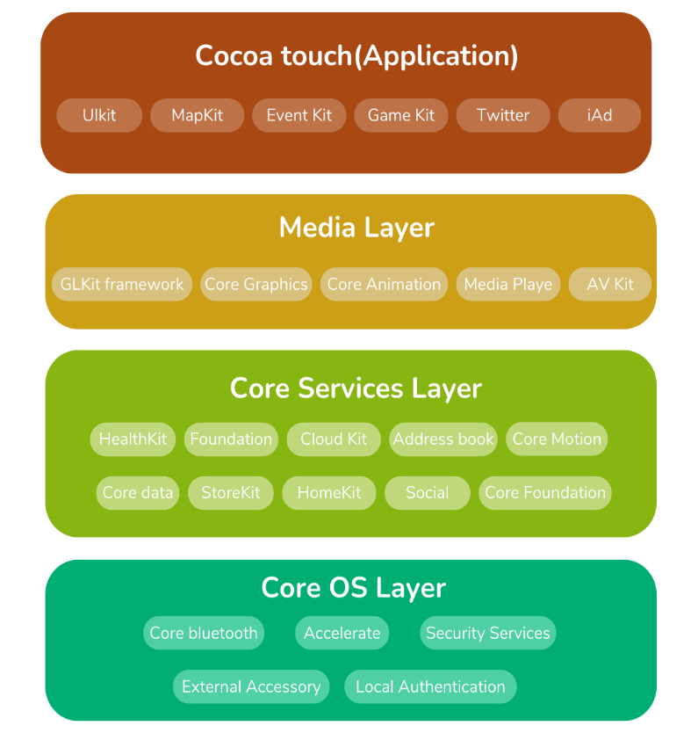

2.3.2 Blackberry OS
BlackBerry OS is a proprietary mobile operating system designed specifically for Research In Motion's (RIM) BlackBerry devices. The BlackBerry OS runs on Blackberry variant phones like the BlackBerry Bold, Curve, Pearl and Storm series.
The BlackBerry OS is designed for smartphone environments and is best known for its robust support for push Internet email. This push email functionality is carried out through the dedicated BlackBerry Enterprise Server (BES), which has versions for Microsoft Exchange, Lotus Domino and Novell Groupwise.

